# Things to be addressed.

## Broken

* Social media links (Fig -1)  
  
* Nav Menu (Fig-2)

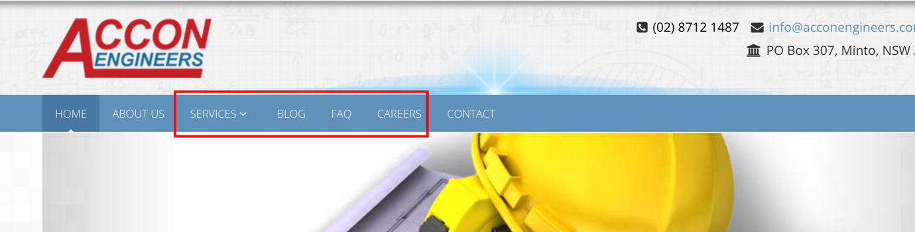

## Missing Meta tags

### TODO’s:

* General meta tags
* Twitter tags
* Facebook tags

### Done:

* New description for home: Discover Excellence in Engineering Solutions with Accon Engineers a premier division of Accon Pty Ltd. Our skilled and motivated team of engineers brings expertise in Civil, Structural, Flood and Drainage, and Geotechnical Engineering.
* New description for about: Accon Engineers: Innovative solutions for residential civil, drainage, and structural design. Quality services with a client-centric approach.
* New title for About page: Crafting Tomorrow's Infrastructure

## Keywords

* Proper distribution of keywords across all sites

## Html Tags

* Proper use of HTML tags like H1, H2
* Missing attributes on image tags

## User tracking

* Enable google analytics

## JavaScript Erros

* Bunch of JS errors, some affecting the performance of the sites

### Meta tags

Description - Elevate your projects with Accon Engineers. Expertise in Civil, Structural, Flood, Drainage, and Geotechnical Engineering. Committed to quality and client relationships for exceptional solutions.

Title- Accon Engineers | {Page name}

Image- Slide 1

Url - <https://acconengineers.com.au/>

Twiter tags

### Home page updates

### 

### Service Page updates

Long title updated with intro text  
  
Comprehensive Engineering Services for a Resilient Future  
  
Welcome to Accon Engineers' Services Page, where innovation meets excellence in engineering solutions. Our expertise is backed by a diverse range of specialized services tailored to meet your specific needs. With a focus on delivering sustainable and forward-thinking solutions, we proudly offer:

Home page:  
  
before:

Accon Engineers as tradie of Accon Pty Ltd was established by a group of highly skilled and motivated engineers. It is one of the leading consultant and we can provide services in Civil, Structural, Flood and Drainage and Geotechnical Engineering.

Our vision is to be recognised as a leading integrated professional services company delivering outstanding value. The company provides quality cost effective services. We take pride in our ability to build and maintain relationships with our clients which allows us to provide a highest level of professional service and design solutions.

No matter how big or small the job, we place our clients’ needs first and resolve the clients job specific needs to their highest level of services.  
  
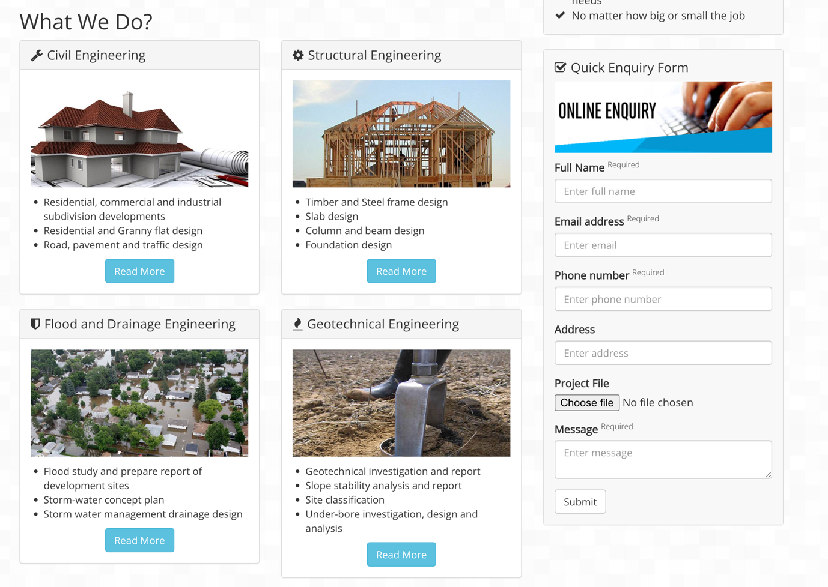

After:

About Page  
  
Before:  
  
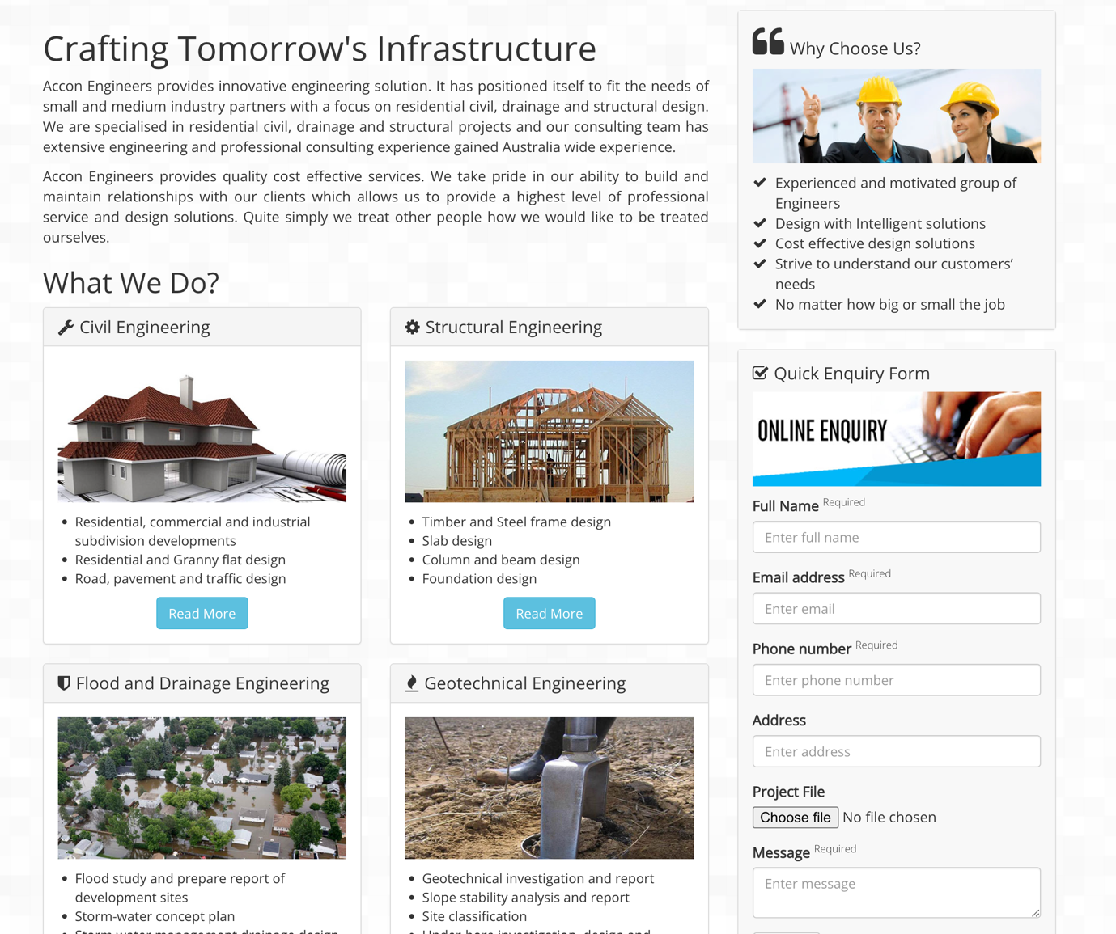

After:

Services:

Before:  
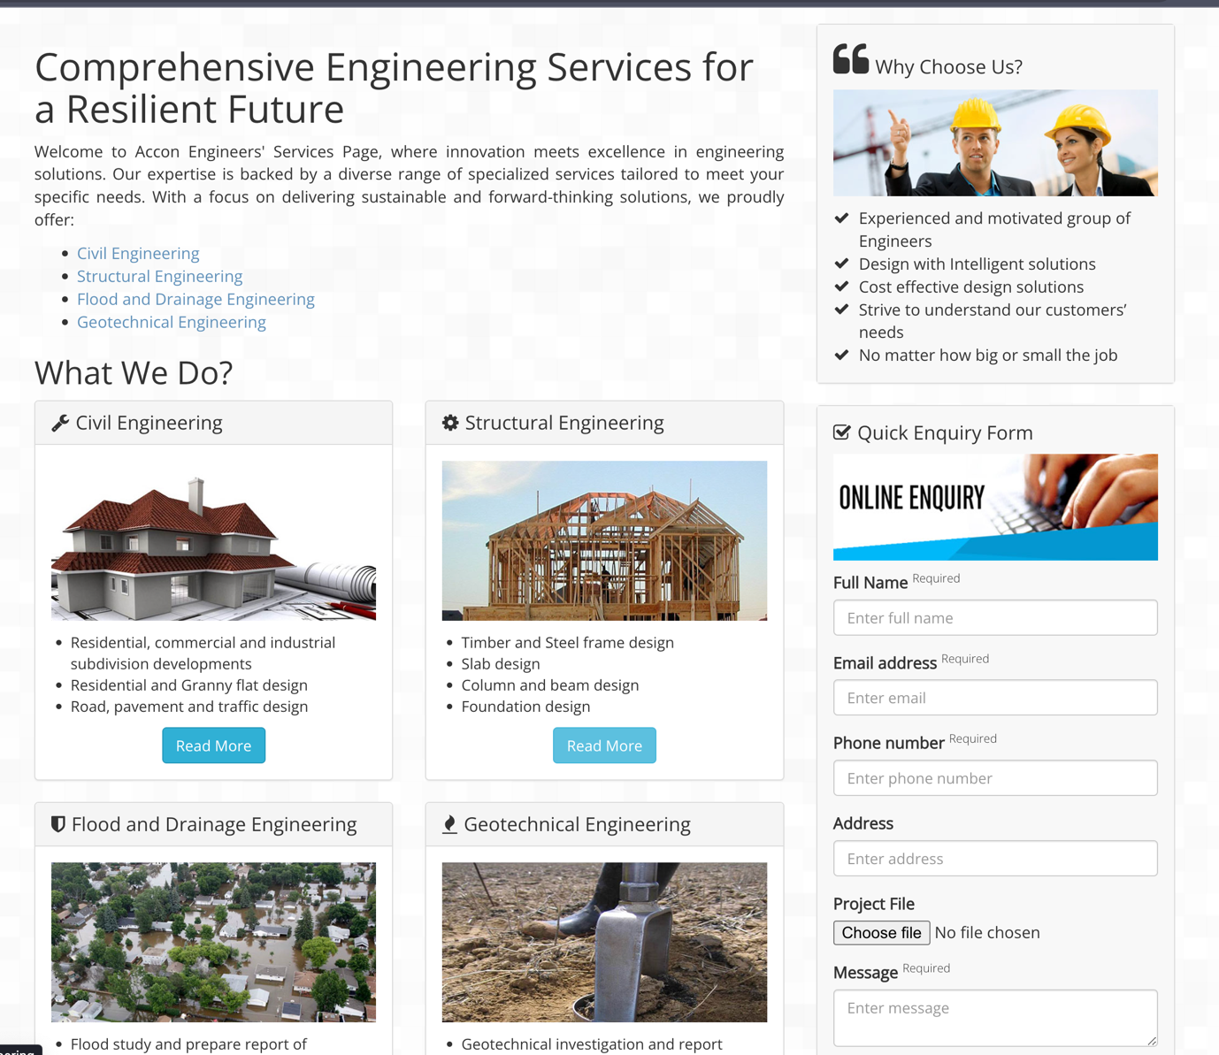

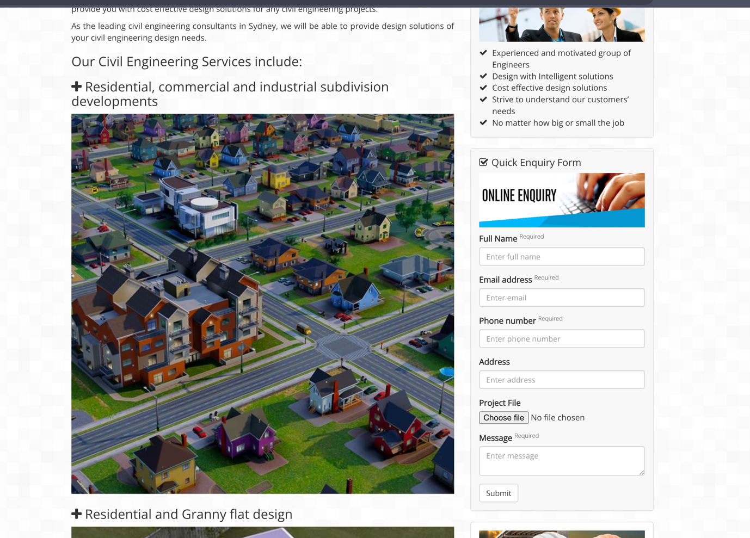  
  
  
After:

Contact Page  
  
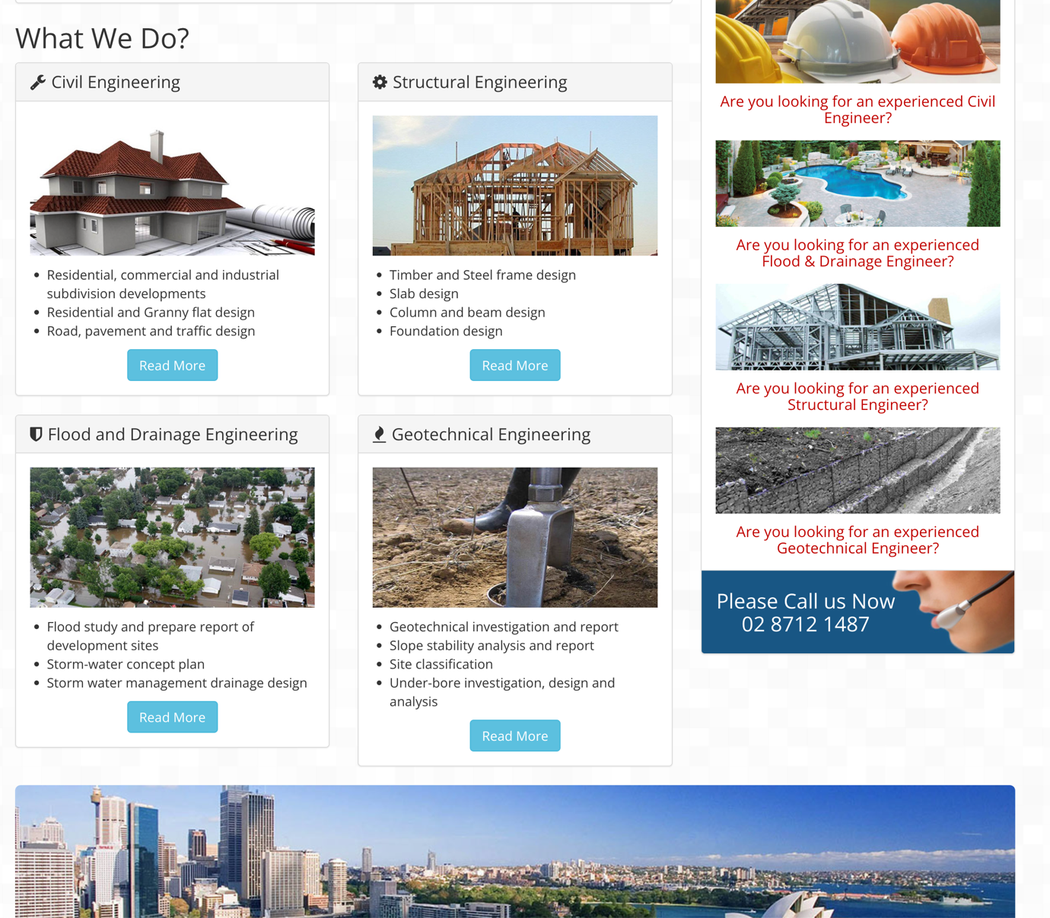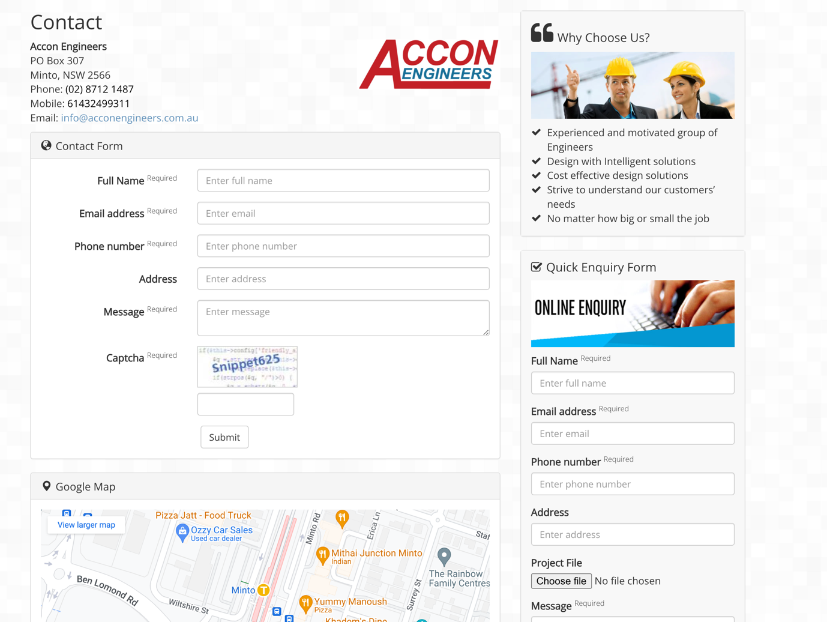

After:

Civil Enginerring content  
before  
Accon Engineers' team of professional, experience, dedicated, creative and innovative engineers can provide you with cost effective design solutions for any civil engineering projects.

As the leading civil engineering consultants in Sydney, we will be able to provide design solutions of your civil engineering design needs.

After

At Accon Engineers, our team of experienced, dedicated, and creative engineers specializes in delivering cost-effective design solutions for a wide range of civil engineering projects.

As the premier civil engineering consultants in Sydney, we take pride in offering tailored design solutions to address all your requirements. Our team's innovative approach ensures that your projects are not only efficient but also compliant with the latest industry standards.

When you partner with Accon Engineers, you gain access to a team that excels in **swept path analysis**, **driveway design**, **civil design**, and **subdivision development** services. Let us bring your civil engineering visions to life while optimizing your project's functionality and cost-effectiveness.

Contact us today to discuss your specific needs and experience firsthand why we are the preferred choice for civil engineering solutions in Sydney.

Structural Engineers Content  
  
Before  
Accon Engineers' team of professional, experience, dedicated, creative and innovative engineers can provide you with cost effective design solutions for any structural engineering projects.

As the leading structural consultants in Sydney, we will be able to provide design solutions of your structural engineering needs.

After:  
  
When it comes to Residential Structural design and Residential Engineering design, look no further than Accon Engineers. Our team of professional, experienced, dedicated, creative, and innovative engineers is well-equipped to deliver cost-effective design solutions for all your structural engineering projects.

As the foremost structural consultants in Sydney, we specialize in providing tailored design solutions to meet your specific residential engineering needs. Whether you're planning a new home construction, a renovation, or any other residential project, we have the expertise and knowledge to ensure your project's success.

At Accon Engineers, we understand the importance of a well-designed and structurally sound residential space. That's why we prioritize delivering high-quality design solutions that not only meet but exceed industry standards. Trust us to bring your residential engineering visions to life and experience the difference of working with the best in the field.

Contact Accon Engineers today to discuss your Residential Structural design and Residential Engineering design requirements. We are committed to helping you achieve your goals with precision, excellence, and efficiency.

Geotechnical Engineering   
  
before  
Accon Engineers' team of professional, experience, dedicated, creative and innovative engineers can provide you with cost effective design solutions for any geotechnical engineering projects.

As the leading structural consultants in Sydney, we will be able provide to design solutions of your geotechnical engineering needs.

after:

When it comes to geotechnical engineering, Accon Engineers is your trusted partner. Our team comprises professional, experienced, dedicated, creative, and innovative engineers who excel in delivering cost-effective design solutions for a wide range of projects. Whether you require a Soil Classification Report, Soil Permeability Report, Geotechnical Investigation and Report, Slope Stability Analysis and Report, Site Classification, Under-Bore Investigation, Design and Analysis, Deep Excavation Investigation, Design and Analysis, or Contaminated Site Investigation, we've got you covered.

As the foremost structural consultants in Sydney, we take pride in providing cutting-edge design solutions for all your geotechnical engineering needs. Our commitment to excellence and in-depth expertise ensures that your projects are executed with precision and efficiency.

Choose Accon Engineers for comprehensive geotechnical engineering services tailored to your specific requirements. Contact us today to discuss how we can help you achieve optimal results for your project.

Flood Drainage enginnering  
  
Before:

Accon Engineers' team of professional, experience, dedicated, creative and innovative engineers can provide you with cost effective design solutions for any flood and drainage projects.

As the leading flood and drainage engineering consultants in Sydney, we will be able to provide design solutions of your flood and drainage needs.

### **Our Flood and Drainage Engineering Services include:**

#### [**Flood study and prepare report of development sites**](https://acconengineers.com.au/#collapse1)

#### [**Storm-water concept plan**](https://acconengineers.com.au/#collapse2)

#### [**Storm water management drainage design**](https://acconengineers.com.au/#collapse3)

#### [**Surface drainage design**](https://acconengineers.com.au/#collapse4)

#### [**Sub Surface drainage design**](https://acconengineers.com.au/#collapse5)

#### [**Infiltration trenches and basin design**](https://acconengineers.com.au/#collapse6)

#### [**Water sensitive urban design**](https://acconengineers.com.au/#collapse7)

#### [**Rain water tank design**](https://acconengineers.com.au/#collapse8)

#### [**On site detention and retention system design**](https://acconengineers.com.au/#collapse9)

#### [**Erosion and sedimentation control plan**](https://acconengineers.com.au/#collapse10)

After:  
  
Looking for expert guidance in flood and drainage engineering? Look no further! Accon Engineers is your go-to source for top-notch services tailored to your specific needs. Our team of professional, experienced, dedicated, creative, and innovative engineers is here to assist you with cost-effective design solutions for a wide range of projects, including:

**Flood Assessment Report** Our experts are well-equipped to conduct comprehensive flood assessments, ensuring your project is prepared for any potential flood risks.

**Flood Impact Report** Accon Engineers can provide you with detailed flood impact reports, outlining the potential consequences of flooding on your site and offering mitigation strategies.

**Flood Risk Management Report** We specialize in developing flood risk management reports to help you navigate and mitigate potential risks effectively.

**Overland Flow Report** Our team can assess overland flow patterns to ensure your site is well-prepared to handle excess water during heavy rainfall events.

**Flood Report** We offer comprehensive flood reports, providing insights into flood patterns and potential impacts on your project.

**Flood Evacuation Plan** Count on us to develop thorough flood evacuation plans, ensuring the safety of your site and its occupants in the event of a flood.

**2D Flood Modelling** Utilizing cutting-edge technology, we employ 2D flood modeling to accurately simulate flood scenarios, helping you make informed decisions.

In addition to our flood-related services, we also excel in various drainage and stormwater solutions, including:

* **Storm-Water Concept Plan**
* **Stormwater Management Drainage Design**
* **Surface Drainage Design**
* **Subsurface Drainage Design**
* **Infiltration Trenches and Basin Design**
* **Water Sensitive Urban Design**
* **Rainwater Tank Design**
* **On-Site Detention and Retention System Design**
* **Erosion and Sedimentation Control Plan**

At Accon Engineers, we take pride in being the leading flood and drainage engineering consultants in Sydney. Our commitment to delivering exceptional design solutions for flood and drainage projects is unmatched. We understand the importance of optimizing your project for safety, efficiency, and environmental sustainability.

Contact us today, and let Accon Engineers be your partner in achieving flood and drainage excellence. Your project deserves nothing less than the best, and we're here to make it happen.

Strom water engineering  
  
When it comes to stormwater engineering, Accon Engineers stands out as the premier choice in Sydney. Our team of dedicated professionals excels in providing innovative and effective stormwater design solutions tailored to your specific needs. With a commitment to excellence, we offer a wide range of services, including:

**Stormwater Engineering** Accon Engineers specializes in stormwater engineering, ensuring your project is equipped to handle even the most challenging water management tasks.

**Stormwater Design** Our experts create comprehensive stormwater designs, optimizing your project for efficient water management and environmental sustainability.

**Stormwater Management Plan** Count on us to develop robust stormwater management plans that adhere to the highest industry standards and regulatory requirements.

**OSD Design (On-Site Detention Design)** We are experts in OSD design, implementing innovative strategies to detain and manage stormwater runoff effectively.

**Water Sensitive Urban Design (WSUD)** Accon Engineers is at the forefront of water-sensitive urban design, promoting environmentally friendly and sustainable stormwater solutions.

**Stormwater Easement Relocation** Our team can assist with stormwater easement relocation, ensuring compliance with legal requirements while optimizing your project's layout.

**Stormwater Concept Design** We offer creative and practical stormwater concept designs, laying the foundation for successful water management in your project.

At Accon Engineers, our commitment to excellence in stormwater engineering is unparalleled. We understand the importance of optimizing your project for safety, efficiency, and environmental sustainability. Our comprehensive services cover all aspects of stormwater management, ensuring your project is well-prepared to handle even the most challenging water management tasks.

When you choose Accon Engineers, you're partnering with a team that not only delivers exceptional stormwater engineering solutions but also prioritizes your project's success. Contact us today to discover how our expertise can elevate your stormwater management efforts. Your project deserves nothing less than the best, and we're here to make it happen.